HAYS COUNTY AIMS AT ENHANCING CONNECTIVITY, RECREATION OPTIONS WITH CAPE'S POND PROJECT

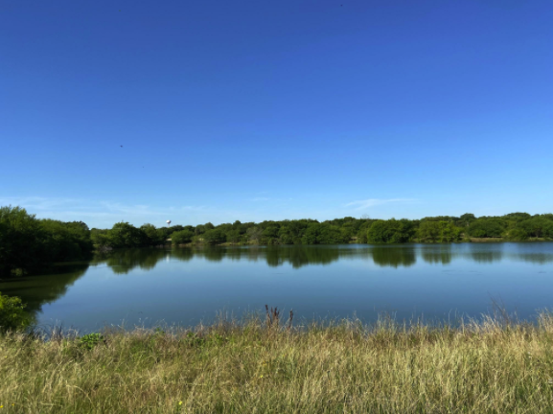
Hays County acquired 28.7 acres of property near the San Marcos river located just east of Interstate 35 and south of River Road, which it plans to use for a project aimed at regional connectivity and recreation options for county residents. Photo courtesy of Hays County
Mon, 07/27/2020 - 6:31pm
Nick Castillo
Managing Editor
@Nick_Castillo74
ncastillo@sanmarcosrecord.com
Hays County is aiming at enhancing and expanding regional connectivity and recreation options for county residents with the acquisition of 28.7 acres of property near the San Marcos River.
The county acquired the land located just east of Interstate 35 and south of River Road for the Cape’s Pond Project through a 2018 transportation bond.
Hays County General Counsel Mark Kennedy said in a press release that the project was discussed as a “key land acquisition to provide multi-modal transportation connectivity between currently disconnected areas of San Marcos and local hike and bike trail systems, including those that are in the planning stages.”
After Kennedy, Precinct 1 Commissioner Debbie Ingalsbe and other county officials met with the Texas Parks and Wildlife Department, the project added a new goal, the county said.
The project has a fish hatchery that is contiguous to the pond property. Those 16 years old and younger can fish for free and any fish that meets Freshwater Bag and Length Limits can be taken and eaten.
“The Parks and Wildlife Department suggested that the pond could qualify for a TPWD grant program known as ‘Neighborhood Fishin,’ which provides alternative outdoor recreational opportunities for local families — and children in particular,” Kennedy said in a statement.
Ingalsbe said that, while she’s pleased about the addition of the fishing program, the connectivity that served as the original conception of the property is “vitally important.”
“County Road 299, also known as Cape Road, is quite dangerous for any form of transportation other than cars,” Ingalsbe said in a statement. “Installing trails along this route would connect neighborhoods on the east side of San Marcos to existing trail systems that, after the IH-35 underpass project is complete, will connect all parts of San Marcos.”

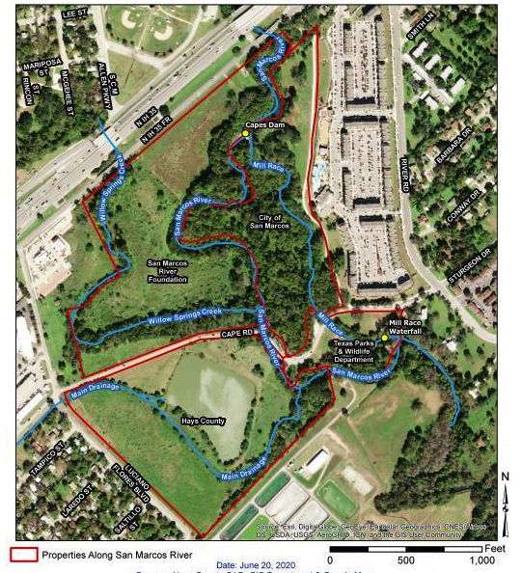
Additionally, the Emerald Crown Trail, which will originate in Kyle and will link with the Violet Crown Trail in Austin, will end only a couple hundred feet downstream of the Cape’s Pond Project, the county said.
“Connection to that trail system would connect San Marcos to much of the region,” Ingalsbe said. She added that the project has environmental positives, such as a riparian area along the river, bank stabilization and additional ecological benefits. The property will also be developed with a small carbon footprint, minimal parking and low impervious cover, Ingalsbe said.
The Precinct 1 Commissioner stated that the project has been submitted to the Hays County Parks and Outdoor Spaces Advisory Committee for inclusion in a possible 2020 bond project. The county’s POSAC will deliver recommendations on prospective parks and open space projects at Tuesday’s Hays County Commissioners Court meeting at 1 p.m.
The San Marcos River Foundation has expressed support of the Cape’s Pond Project, the county said. SMRF Executive Director Virginia Condie said the county’s land acquisition is an important purchase for county residents.
“SMRF is thrilled that the county purchased this property on the east side of I-35,” Condie said in a statement. “Located across the river from Stoke's Park and adjacent to the fish hatchery, it has trees, beautiful wildflower fields, spectacular river frontage and a very large pond. The neighborhoods in the area will be very happy to see this become a park with fishing access and protection of the riverbank.

